**Project: Student Database Management System (Postgresql)**

**Objective:** Design and implement a Student Information Management System using PostgreSQL. The project aims to create a database to efficiently store and manage student data. The system will perform tasks such as database setup, data entry, information retrieval, updates, and calculations.:

1. **Database Setup**

Create a database named “student_database.”

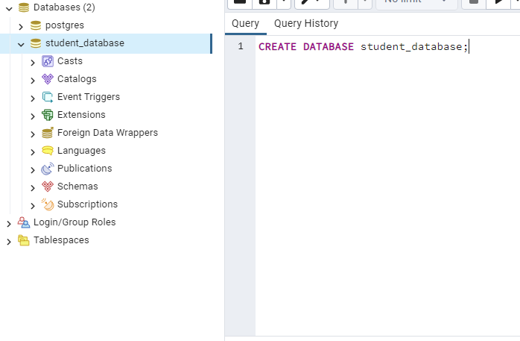

Create a table called “student_table” with the following columns: Student_id (integer), Stu_name (text), Department (text), email_id (text), Phone_no (numeric), Address (text), Date_of_birth (date), Gender (text), Major (text), GPA (numeric), Grade (text) should be A,B,C etc.

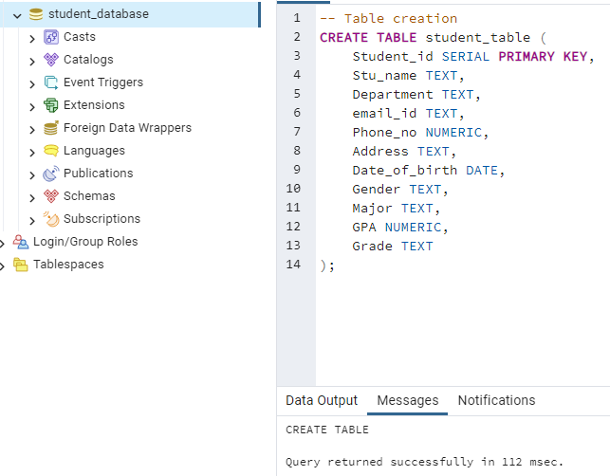

1. **Data Entry:**

Insert 10 sample records into the “student_table” using INSERT commands.

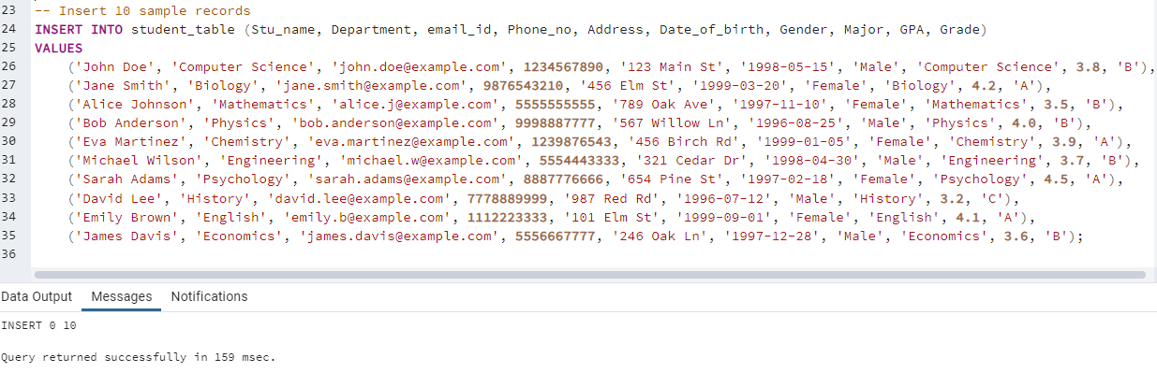

1. **Student Information Retrieval:**

Develop a query to retruve all students informations from the “student_tabel” and sort them in descending order by their grade.

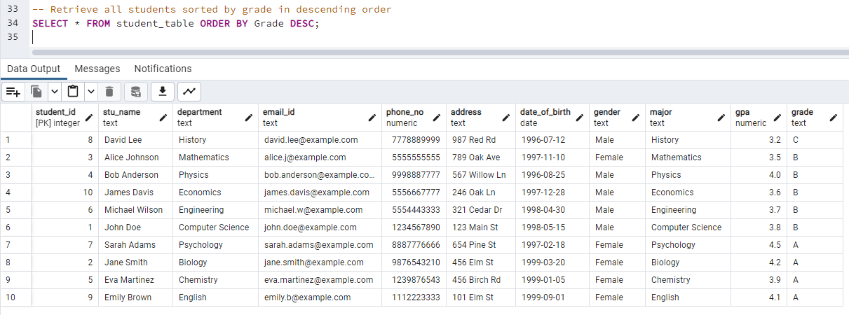

1. **Query for male Students:**

Implement a query to retrieve all student’s information about all male students from the “student_table.”

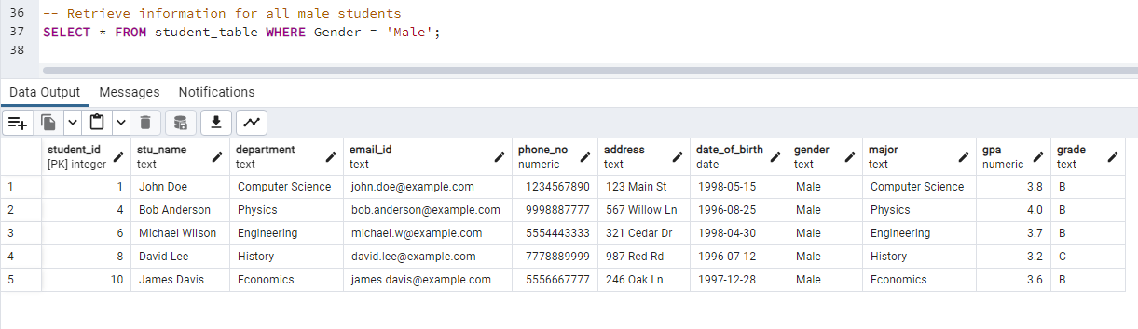

1. **Query for students with GPA less than 5.0**

Create a query to fetch the details of students who have a GPA less than 5.0 from the “student_table.”

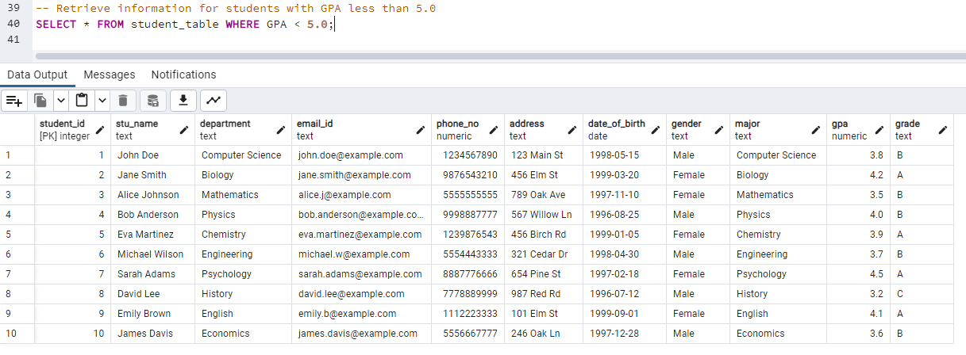

1. **Update student email and grade:**

Write an update statement to modify the email and grade of a student with a specific Id in the “student_table”

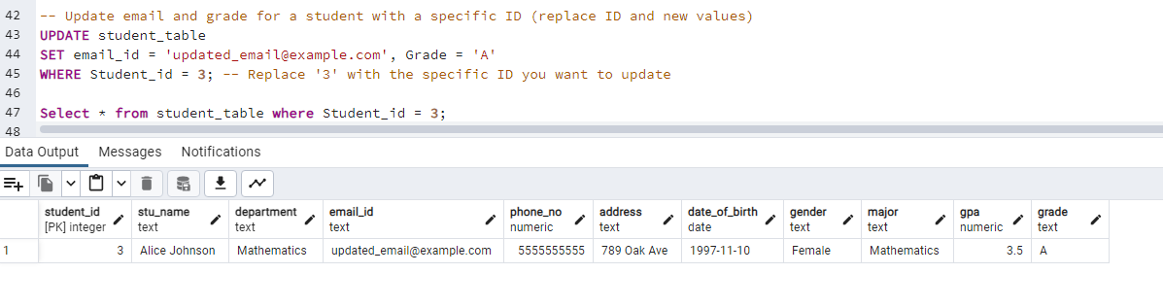

1. **Query for students with Grade “B”.**

Develop a query to retrieve the names and ages of all students who have a grade of “B” from the “student_table”.

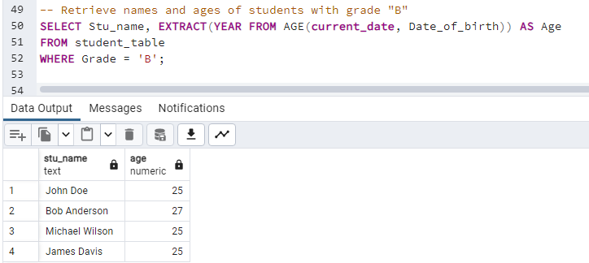

1. **Grouping and Calculation**

Create a query to group the “student_table” by the “ Department” and “Gender” columns and calculate the average GPA for each combination.

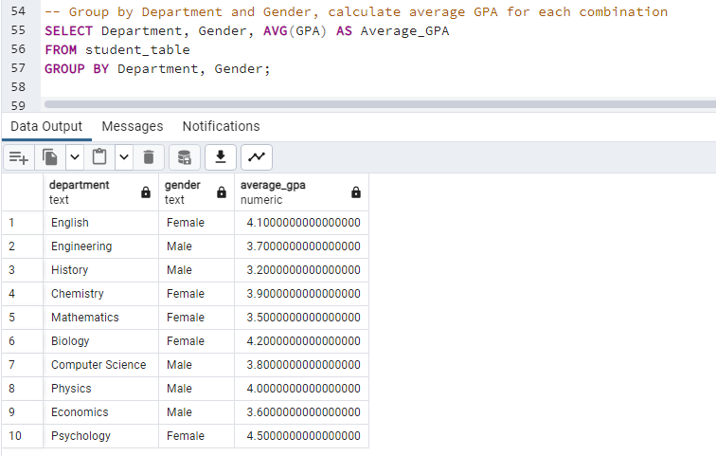

1. **Table Renaming:**

Rename the”student_table” to “student_info” using the appropriate SQL statement.

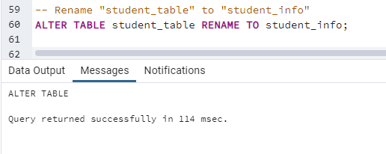

1. **Retrieve Student with Highest GPA**

Write a query to retrieve the name of the student with the highest GPA from the “student_info” table.

